DHA Suffa University

Department of Computer Science

Final Year Project



**Maid In**

**Project Proposal**

Submitted by

Inam Ullah (Student Id)

Faisal Zaman Haider (Student Id)

Poorab Gangwani (Student Id)

Supervisor(s)

Arifa Mustafa

Huma Jamshed

In partial fulfilment of the requirements for the degree of

Bachelor of Science in Computer Science

2021

**Document Sign off Sheet**

### Document Information

|  |  |
| --- | --- |
| **Project Title** | Maid In |
| **Document** | Project Proposal |
| **Document Version** | 1.0 |
| **Identifier** | FYP01-PP |
| **Status** | < Draft/ Final / etc..> |
| **Author(s)** |  |
| **Approver(s)** |  |
| **Issue Date** |  |

Team Lead Name: Inam Ullah Signature: Date:30/03.2021

Member 1 Name: Faisal Zaman Hayder Signature: Date: 13/10.2022

Member 2 Name: Poorab Gangwani Signature: Date:13/10.2022

Supervisor Name: Arifa Mustafa Signature: ______________ Date: ________

Co-Supervisor Name: Huma Jamshed Signature: ______________ Date: ________

**CS Project I Coordinators:**

Name: ___________________________ Signature: ____________________ Date: __________

Name: ___________________________ Signature: ____________________ Date: __________

**Revision History**

|  |  |  |  |
| --- | --- | --- | --- |
| **Date** | **Version** | **Description** | **Author** |
| 13/04/2021 | 1.0 | initial document |  |
|  |  |  |  |
|  |  |  |  |
|  |  |  |  |

### Definition of Terms, Acronyms, and Abbreviations

*[This section should provide the definitions of all terms, acronyms, and abbreviations required to interpret the terms used in the document properly.]*

|  |  |
| --- | --- |
| **Term** | **Description** |
| Maid In | Name of the Application |
| Agile | Software Development methodology |
| UI | User Interface |
| UX | User Experience |
| JS | JavaScript |
| OS | Operating System |
| React JS | JavaScript Web Framework |
| MongoDB | Open-source cross-platform domestic-oriented database program |
| React Native | Open-source UI software framework |

### Table of Contents

Document Information 2

Definition of Terms, Acronyms, and Abbreviations 2

Table of Contents 3

1 Introduction

1.1 Problem Statement  
 1.2 Product Position Statement  
 1.3 Project Motivation and Background  
 1.4 Objectives  
 1.5 Literature Review and GAP Analysis

2 Project Vision

2.1 Business Case and SWOT Analysis

2.2 Stakeholder Summary

2.3 User Summary

2.4 Business Objectives and Success Criteria

2.5 Project Risks and Risk Mitigation Plan

2.6 Assumptions and Dependencies

3 Project Scope

3.1 In Scope

3.2 Out of Scope

4 Proposed Methodology

4.1 SDLC Approach (Waterfall/Agile/Spiral)

4.2 Team Role & responsibilities

4.3 Requirement Development Methodology

4.4 High level Architecture / Design

4.5 Application (or Project) Testing Methodology

5 Project Planning

5.1 Gantt Chart

6 Project Requirements

6.1 Software tools requirements

6.2 Hardware requirements

7 Budget/Costing

7.1 Estimated Budgeted Cost of the Project

8 Project Deliverables (you may change according to your project methodology)

8.1 Phase I - Alpha Prototype

8.2 Phase II - Beta Prototype

8.3 Phase III - Release Candidate

8.4 Phase IV - Final Product

9 Proposed GUI (Prototype)

10 Meetings held with supervisor and/or client.

11 References

**1 Introduction**

* 1. **Problem Statement**

|  |  |
| --- | --- |
| **Problem** | Many service industries in Pakistan have seen great shift to digitalization and utilization of online platforms to increase accessibility and productivity for its customers. Domestic service industry has mostly been neglected in such treatment and still adheres to old inadequate practices for providing service opportunities which renders it a very time-intensive and undesirable process. There are no recognizable online platforms for connecting people of the domestic service industry and for promoting awareness in regards to availability of suitable and affordable services |
| **Affects** | Domestic service serves as a source of subsistence and survival to a large chunk of the populace in Pakistan and is virtually required in every household for management and control but due to the aforementioned problems they face difficulty in gaining access to and obtaining services that suite their needs |
| **Impacts** | Due to the lack of technological advances in the industry, hardship is unnecessarily incurred by both domestic workers and people seeking their service as they are very much restricted to primitive and manual methods for getting the know-how of the different prospects available out there for them like personal enquires, 3rd party agencies etc. all of which make the process burdening and inefficient for them. |
| **Solution** | An online mobile platform equipped with many modern tools and facilities replacing the primitive ways of approaching domestic service employment for both customer and domestic worker, allowing online conducting of business transaction, interactive communication, and improving the overall experience for both |

**1.2 Product Position Statement:**

For domestic service industry where patrons lack strong technological tools for seeking suitable domestic work employees who, in turn, also face difficulties in gaining access to opportunities of sustainable domestic work, **Maid In** is a mobile platform that helps in alleviating such encumbrances through various technological solutions.

Unlike many previous applications that have tackled such issues, **Maid In** differs in aspects where it provides considerably more features to accommodate and expedite the domestic service process some of which includes online interactive communication capabilities between both parties, real time map assistance and much more.

**1.3 Project Motivation and Background**

The system for domestic house service, especially in developing areas like Pakistan has had severe disadvantages of disorganization, lack of strong accessibility and improper planning in regards to fixed wages, working hours and tasks etc.

Moreover, it is dependent on weak and unreliable hiring processes which most of the times involve word of mouth through friends, relatives or family

Many of these aforementioned imperfections are disastrous to the domestic household service industry and more so for domestic workers as many men and women in Karachi rely on domestic services for subsistence and survival with no proper structure to aid them.

Through our application, we aim to lessen these imperfections as much as possible and inculcate better practices into the domestic service employment.

* 1. **Objectives**
* To provide domestic workers with a platform that gives them insight and opportunity pertaining to potentially open work requiring their specific expertise.
* To provide online platform for negotiation between customer and hired help to overall strengthen work process by establishing mutually agreed upon work elements such as work hours, status, task etc.
* To provide domestic service patrons with the ability to reach out to reams of prospective domestic workers quickly and easily
* To provide technological structure to domestic service industry

**1.5 Literature Review and GAP Analysis**

***Domestic Android Application for home services:***

It inform on the basic functionality and modules implemented in such subject matter to constitute a mobile application some of which are registration of customers and service providers, specification of service types available, customer ratings and feedback on said services etc. while also pointing out some of the flawed practices in an application of such nature some of which are manual allocation of service requests to service men through administrator or scarcity in service types in the application.(System 1)

***Android Application on Domestic Service:***

It elaborates on the common functions and services of a domestic service application while also bringing to light the hindrances and complexities of data management in table format databases for such an application and other disadvantageous negations as well some of which are refraining from use of android GPS services in favor of manual location inputs which ultimately result in unnecessary time consumption and resource wastage in the application. It promotes many safer and efficient practices to expedite domestic service applications some of which are:

* Centralized database repository to streamline handling of application data
* Usage of GPS services like tracking, locating, distancing etc.

(System 2)

***From domestic servant to domestic worker:***

It touches upon the historical difficulties and legal hardships incurred by the domestic work sector all the while also shedding light on the sectoral disadvantages levelled against the profession and how past legal unjust has influenced the current legal situation of domestic work.

Many different forms of domestic service like **menial labor (live-in)**, **apprenticeship**, **laboring** have been remarked on along with the close and personal working relationship derived from such arrangements between employer and employee. It call upon historical legal judgements and customs that had been agreed to and enforced exclusively for the domestic work group concerning various elements like work notice, hiring protocols etc.

***Domestic workers-legal protection mechanisms in Pakistan:***

It narrates on the progress in regards to the legal recognition and compensation of domestic services as well as it’s providers through implementation of legislative bills such as **Punjab Domestic Workers Act, Islamabad Capital Territory Domestic Workers Act, 2019** etc. and the intention of which was to bring domestic workers under the jurisdiction of labor laws.

Some important and insightful statistics were provided pertaining to domestic service in regards to employment in developing countries (10%), it’s majority in informal sector of Pakistan along with the legal eligibility and prerequisites of domestic employment in regards to age, minimum wage etc.

***Development of App to provide blue collar services to the public:***

It states briefly on the emergence of online service platforms based on areas of business such as transportation, food service, grocery and retail etc. and how they have quickly permeated into the everyday life of individuals and made It easier and less encumbering while also briefly stating on the effect of laziness it produces on the human life.

It emphasizes on a mobile application designed to intensify communication and service between blue collar workers and the average employer, where one side is provided with online facilities suited for their needs to engage with the other side in order to hire/procure service.

It discusses many possible features and elements applicable in domestic service apps like selection of membership to avail certain privileges, work limit and renewal charging, customer task advertisement and notification etc. (System 3)

**GAP Analysis:**

|  |  |  |  |  |
| --- | --- | --- | --- | --- |
| **Features** | **Our System** | **System 1** | **System 2** | **System 3** |
| **Access to myriad of domestic services** | **Yes** | **Yes** | **Yes** | **Yes** |
| **handling online financial**  **transactions** | **Yes** | **No** | **No** | **No** |
| **Messaging and other communication capabilities** | **Yes** | **No** | **No** | **Yes** |
| **Map display for location and tracking** | **Yes** | **No** | **No** | **No** |
| **Setting conditions such as work duration or proximity to user residence** | **Yes** | **Yes** | **Yes** | **Yes** |

**2 Project Vision**

**2.1 Business Case and SWOT Analysis**

**Business Case:**

Our business case is the fulfillment of an opportunity pertaining to the still manually handled business processes of domestic service industry through automation and implementation of a business model involving usage of an online platform intended to minimize the numerous immemorial practices persisting in the industry such as lack of digitalization, inaccessibility, dependence on inefficient non-technological means.

As stated, the strategies and frameworks are still rooted in very old and irrelevant practices where customers and providers have very little technological support them in the process due to the scarcity of recognizable online services, software and other possible mediums and thus they are limited to non-secure facilities like service agencies or physical enquires which do not provide assurance in the quality of the service.

Our **Solution** will be giving a technological treatment to the domestic service industry similar in nature and purpose to services like bykea, careem etc. and connect all the customers and providers onto a single platform where they will be capable of reaching out and creating awareness of their needs and be well-informed on the opportunities around them and within their reach while also allowing them to maintain transactions digitally instead of having to adhere strenuous physical processes like meet and greet or interviews.

Through our application, customers can register and login to be presented with facilities which enable them to expeditiously seek domestic services, make payments online, decide working hours and have quick contact to providers.

**SWOT Analysis**

|  |  |  |  |  |
| --- | --- | --- | --- | --- |
|  | **Strengths** | **Weaknesses** | **Opportunities** | **Threads** |
| 1 | Improved accessibility and communication between customer and provider | Disallows direct face to face communication | Increased business for domestic service providers | Undefined business model |
| 2 | Maintenance and management of transaction records for both parties | Fluctuation of performance due to varying strength of internet | The printed nature of transaction data management can act as some form of contractual agreement thus providing legal security in case of infraction | Prone to cyber crimes |
| 3 | Secure payment system |  | Comparatively less market saturation potentially leading to higher growth and gain | Competition from similar service products |
| 4 | Up-to-date information pertaining opportunities, current work engagements and task management |  | Increased options of domestic service types for variety in accommodation to users |  |

**2.2 Stakeholder Summary**

|  |  |  |
| --- | --- | --- |
| **Type** | **Description** | **Responsibilities** |
| Supervisor | Overseer of the project | Manage and guide the software development process, it’s documentation, evaluation, feasibility and overall completion |
| Development team | Developers and programmers of the software | Research, design, and develop the software features, user interface and programs to be used by end users |
| End user | Users of the software | Utilize the system functionality for it’s intended purpose and provide feedback regarding issues |
| Software Tester | Testers of the software | Perform standard testing protocols and practices on the developed software and it’s components for discovery of possible bugs or errors and provide reports to development team regarding findings |

**2.3 User Summary**

|  |  |  |  |
| --- | --- | --- | --- |
| **Name** | **Description** | **Responsibilities** | **Stakeholder** |
| Customer | Who uses the application to reach out to service providers | * Must expressly specify desired service types, location for service, task duration and all other customary information. * Will hire ,cancel or request any available service provider that fits his requirements |  |
| Provider | Who registers his qualifications into the system for accessibility to service opportunities | * Offer and negotiate his services to any of the prospective clientele available to him * Maintain a ledger of his transactions with customers |  |

**2.4 Business Objectives and Success Criteria:**

|  |  |
| --- | --- |
| **Business Objectives** | **Success Criteria** |
| Connect customers to suitable domestic service workers with expedition | System records service requests and through a map isolates all domestic service agents befit for the service and within 50km proximity to customer’s current location in under 5 minutes |
| Privy domestic service workers to available service opportunities | record service requests and inform of its status of availability in real-time to every registered service agent in the system whose occupation satisfies the service required |
| Increase and streamline communication between customers and domestic service workers | allowing users access to real-time communication features (voice calls, chats, video calls ) with potential service agents as well as agents they are currently in transaction with |
| allow online monetary transactions between customers and domestic service workers | System implemented payment gateway used in conducting financial transactions for both parties in a matter of minutes |

**2.5 Project Risks and Risk Mitigation Plan**

**Project Risks:**

|  |  |  |
| --- | --- | --- |
| **Risk Type** | **Probability** | **Effects** |
| Technology incompatibilities pertaining to libraries, modules, or frameworks | Medium | Tolerable |
| Delays in completion of tasks | Medium | Moderate |
| Emergency of new and unpremeditated tasks by stakeholders or other external agents. | High | Tolerable |
| Infeasibility of completion before deadline | Medium | Severe |
| Non-fulfilment of responsibilities due to personal constraints or problems befalling team members | High | Tolerable |

**Risk Mitigation Plan:**

1. Implement agreeable substitutes to faulty modules without hampering the overall planned flow and functionality of the project.
2. Increase work hours and seek expert guidance to make up for delays in task completion
3. In case of impossibility of project completion under presented circumstances, elimination of inconsequential, ornament features and relatively less contributing features will be done.
4. Division of tasks previously to be handled by suddenly indisposed members to remaining team members

**2.6 Assumptions and Dependencies**

**Assumptions:**

1. Users have access to sturdy internet connectivity
2. Users have access to necessary mobile devices for downloading and setting up application
3. Users have sufficient memory storage to support the functionality of the application

**Dependencies:**

1. User must provide sensitive personal information and location statistics.
2. Users must have email and account credentials

**3 Project Scope**

**3.1 In Scope**

* + - Varied collection of domestic services to choose from and autonomy to decide preferred help
    - Different channels of communications namely chatting and voice calling.
    - Secure data storage of personal information from registration
    - Authentication and verification of user with login
    - Mapping and location tracking capabilities
    - System for management of online monetary transactions
    - Aiding and search and filter of potential house help through parameters such as price range, location, work duration
    - Editing capability towards content personally inputted into the application
    - Profile creation and maintenance

**3.2 Out of Scope**

* . Built-in training tutorial or guidance to familiar with the interconnected functioning of the application components
* Facility for conveying personal grievances and issues towards application performance or functions

**4 Proposed Methodology**

**4.1 SDLC Approach (Waterfall/Agile/Spiral)**

The software development methodology to be utilized in the development of the application will be the traditional **waterfall** approach where the whole sequential process will constitute the following:

* **Requirement gathering and analysis**

We will gather and assimilate the necessities and appropriate information pertaining to the application and its components.

* **Design**

Based on the knowledge we will have derived from the requirements documentation, we will further create and structure specific designs such as **ERDs**, **Use Cases**, **flow diagrams** etc.

* **Implementation**

We will collectively and individually develop the planned out modules, units and components with proper coordination and synchronization.

* **Testing**

We will formally prepare test cases and protocols to apply to the application after the conclusion of its development process for further validation.

An additional preliminary stage of **pre-planning** will be followed before proper commencement of the waterfall process where certain activities like brainstorming, research, feasibility studies and relevance pertaining to the application and the technological implementation of its subject matter (i.e. domestic services) will be considered.

**4.2 Team Role & responsibilities**

Name– Arifa Mustafa

Name – Huma Jamshed

Name – Inam Ullah

Responsibilities –

* Proposal
* UI/UX
* Frontend
* Backend
* Database
* Testing

Name – Faisal Zaman Haider

Responsibilities –

* Proposal
* UI/UX
* Frontend
* Backend
* Database
* Testing

Name – Poorab Gangwani

Responsibilities –

* Proposal
* UI/UX
* Frontend
* Backend
* Database
* Testing

**4.3 Requirement Development Methodology**

**Data Collection:**

Through study and analysis of many previously published papers on the subject of domestic service, it’s prerequisites, traditional work structure and up till now technological implementation as a service product, many crucial and helpful data points were collected. We learned about the eligibility criteria associated with such services in many areas such as age, fitness etc. while also being guided on the software modules and features customary to such applications or having had involvement in many of the products that have tackled the subject matter such as mapping technology, messaging between customer and domestic service provider etc.

**Analysis and Design:**

**Modules / Panels:**

The Design is consist of different Panels Which Contain Different Role and features that will created to make that possible here are some of the modules

**Admin Module / Panel:**

This module will controll all other modules and will acquire the ability to take controll of every other Module and panel

**Analyzation Module:**

This will contain all the analyzation and visualization of the application in the form of Dashboard. It will monitor the all the panels and the flow, working of that panels like request and response visualization, payment visualization, earning visualization etc.

**Monitoring Module Request / Responses And Users / Providers:**

The admin will be able to monitor the whole application requests and responses that are being made by the client and provider its acceptance its rejections and with the details

**Transactions Leaguer:**

This will contain all the transactions and its details and it will only be available to admin

**Reviews Module:**

It will contain all the reviews of the application that will help in decision making of the admin

**Client Module / Panel:**

Client module will cover all the details of features that

**Map Module:**

This will contain the map which will be use to locate the service provider

**Booking / Cancelling / Reporting Module:**

This will contain all the features to book cancel and reporting of

Client panel

**Payment Module:**

It will contain all the features that will cover all the transaction process

**Notification Module:**

This will contain the notification feature

**Provider Module / Panel:**

**Manage Profile:**

Driver will be able to make changes to their profile as per situation

And these will also contain pass and email changes

**Payment / Bank Details:**

Driver will be able to add their bank account to their profile and will also change it also they can integrate any payment as per their need

**History:**

The is able to access the history records that is associated to the profile

**Earnings:**

Will able to view the earnings and its history through graphs and lists

**Map:**

The map feature will also be included in the provider module to keep an eye on the client

**Notification:**

The notification feature will also be added to the provider panel to keep track of the activity of the panel

**Request List:**

The module the will cover the booking requests and the responses

**Observer Module / Panel:**

**Development and Implementation:**

For Development We Will Use These Technologies:

* + - React Native
    - Flexbox
    - Node JS
    - Express JS
    - Graph QL
    - Apollo
    - Mongo DB

For front- end we will use react-native framework. It’s an amazing way to create amazing User Interface the main reason for selecting the react native framework is that it uses JavaScript. JavaScript is widely use language in a market now a days

For back-end we will use Node JS framework. Node Contain Almost Every Module to resolve any problem. The main reason to select Node JS is it uses JavaScript so we don’t have to learn another programming language to create backend. It will be great for the scalability of the application

For the server will use Express JS or Apollo for data medium the reason for using these servers is that matches the scalability of MERN Stack

For the database we will use the Mongo DB. Mongo is non-relational database use to handle big data and that is perfect for these kind of applications B2B applications mostly deals with big data which can be done using mongo DB

**Testing:**

Some of the testing techniques that will be applied to ascertain the application will be:

* **Unit Testing**

It will be performed individually and collectively during the development of the application and its unit to ensure their quality and expected functioning

* **Black box Testing**

It will be performed by testers neither involved in nor knowledgeable to the backend work flow and execution of the application in order for us to gain some understanding of an end user’s perspective on the working of the application

* **Sanity Testing**

Bugs and errors will be certain to happen in the development of various components of our application due to many possible occurrences and so when they have been dealt with, we will perform mandatory testing to determine whether the implemented remedies and fixes were successful in removing the errors in the application or have created more flaws.

* **White box Testing**

This is testing we will perform through stakeholders well-versed in the working of our application (backend, database, logic flow etc.) and will be performed by our supervisors or anyone else who fits the criteria. It will be applied to provide us insight into parts of the internal structure where performance will could be amiss.

* **Regression Testing**

It is testing we will perform as the development proceeds and newer additions or updating pertaining to units or modules will be done into our software by us to ensure that our software functionality has not been compromised due to the changes.

* **Integration Testing**

As our application will have multitude of modules like **registration**, **login**, **Home Page** etc. which will all be directly or indirectly linked to constitute the entire working of the application, we will perform testing upon integration of these modules with each other to gain awareness of possible encumbrances that could have been produced as result of the integration.

**4.4 High level Architecture / Design**

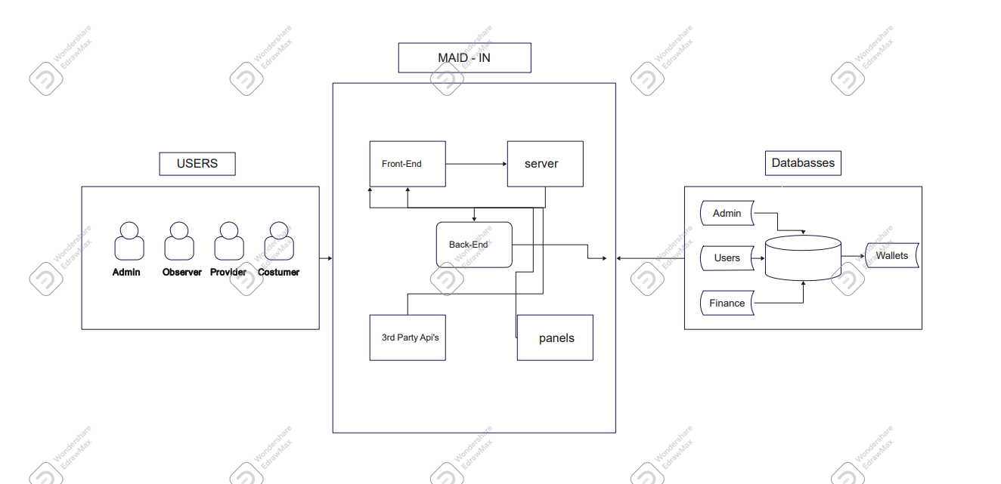

**Project Planning**

**5.1 Gantt Chart**

**6 Project Requirements**

**6.1 Software tools requirements:**

* VS Code
* Android Studio
* Insomnia
* Git / GitBash
* React JS
* MongoDB
* React Native
* React Navigation
* Node JS
* Express JS

**6.2 Hardware requirements**

* Windows / Linux OS/ Mac OS

**7 Budget/Costing**

**7.1 Estimated Budgeted Cost of the Project**

* + Total Hours – 350 Hours
  + Per Hour Rate – 1000/- Rs
  + Total Hours Rate – 350,000/- Rs
  + Hardware Cost - -- 112,938/- Rs
  + Other resources –
    - – Cloud Server 66,300/-- Rs
    - – Deployment 24,000/-- Rs
    - – Third Party Api’s (Google Map, Payment Methods, Data) 66,300/-- Rs
  + **Total cost Rs. 619,238 / =**

**8 Project Deliverables (you may change according to your project methodology)**

**8.1 Phase I - Alpha Prototype**

1. Structure
2. **Customer Panel** (UI/UX - GUI )
   * + Design

– Development (Front-end, Backend, Database)):

* + - Login/ Signup
    - Messaging
    - Payment
    - Wallet
    - Price Negotiation feature
    - Map integration / Features
    - Service Categories
    - Bookings
    - Reviews
    - Notifications
    - Complains

1. **Provider Panel:**

– Development (Front-end, Backend, Database)):

* + - Design
    - Login / Signup
    - Messaging
    - Wallet
    - Price Negotiation
    - Map Integration
    - Request Leaguer
    - Accept / Reject / Overdue
    - Profile Management
    - History Of Booking Transactions
  1. **Phase II - Beta Prototype**

1- Structure

1. **Customer Panel** (UI/UX - GUI )
   * + Design
     + Documentation

– Development (Front-end, Backend, Database)):

* + - Login/ Signup
    - Messaging
    - Payment
    - Wallet
    - Price Negotiation feature
    - Map integration / Features
    - Service Categories
    - Bookings
    - Reviews
    - Notifications
    - Complains

1. **Provider Panel:**

– Development (Front-end, Backend, Database)):

* + - Design
    - Documentation
    - Login / Signup
    - Messaging
    - Wallet
    - Price Negotiation
    - Map Integration
    - Request Leaguer
    - Accept / Reject / Overdue
    - Profile Management
    - History Of Booking Transactions

**Observer Panel**

– Development (Front-end, Backend, Database)):

* + - Design
    - Documentation
    - View Only Mode
    - Map Integration
    - Global Map View
    - Login / Sign Up

**8.3 Phase III - Release Candidate**

1- Structure

1. **Customer Panel** (UI/UX - GUI )
   * + Design
     + Documentation

– Development (Front-end, Backend, Database)):

* + - Login/ Signup
    - Messaging
    - Payment
    - Wallet
    - Price Negotiation feature
    - Map integration / Features
    - Service Categories
    - Bookings
    - Reviews
    - Notifications
    - Complains

1. **Provider Panel**:

– Development (Front-end, Backend, Database)):

* + - Design
    - Documentation
    - Login / Signup
    - Messaging
    - Wallet
    - Price Negotiation
    - Map Integration
    - Request Leaguer
    - Accept / Reject / Overdue
    - Profile Management
    - History Of Booking Transactions
    - Setting

1. **Observer Panel**

– Development (Front-end, Backend, Database)):

* + - Design
    - Documentation
    - View Only Mode
    - Map Integration
    - Global Map View
    - Login / Sign Up
    - Setting

**8.4 Phase IV - Final Product**

1. Structure
2. **Customer Panel** (UI/UX - GUI )
   * + Design
     + Documentation

– Development (Front-end, Backend, Database)):

* + - Login/ Signup
    - Messaging
    - Payment
    - Wallet
    - Price Negotiation feature
    - Map integration / Features
    - Service Categories
    - Bookings
    - Reviews
    - Notifications
    - Complains
    - Setting

1. **Provider Panel:**

– Development (Front-end, Backend, Database)):

* + - Design
    - Documentation
    - Login / Signup
    - Messaging
    - Wallet
    - Price Negotiation
    - Map Integration
    - Request Leaguer
    - Accept / Reject / Overdue
    - Profile Management
    - History Of Booking Transactions
    - Setting

1. **Observer Panel**

– Development (Front-end, Backend, Database)):

* + - Design
    - Documentation
    - View Only Mode
    - Map Integration
    - Global Map View
    - Login / Sign Up
    - Setting

**5 – Admin Panel**

– Development (Front-end, Backend, Database)):

* + - Design
    - Documentation
    - Login / Signup
    - Dashboard
    - Reviews
    - Complete / Schedule Requests
    - Cancellations / Reasons
    - Map View
    - User’s List
    - Service Provider’s List
    - Partner’s
    - Service Type (Crud Operation)
    - Payments
    - Setting

**9 Proposed GUI (Prototype)**

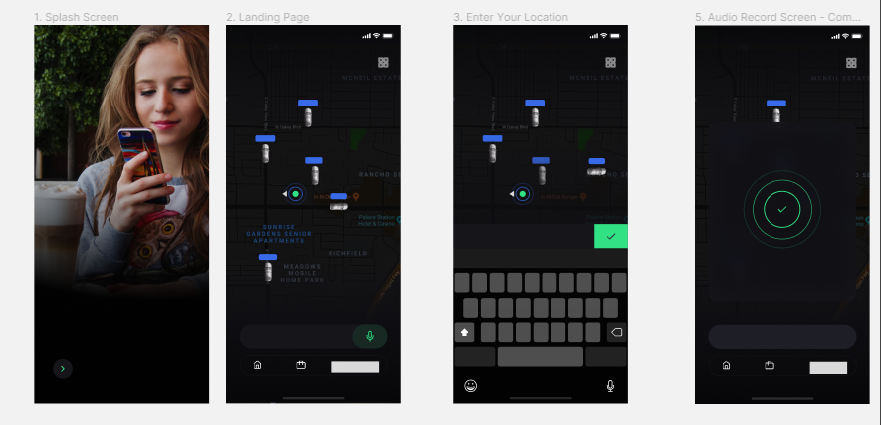

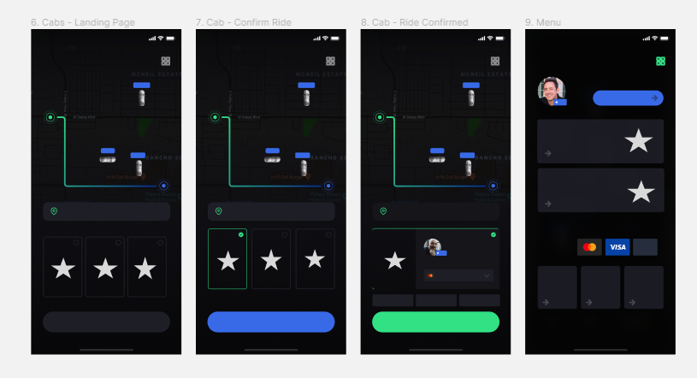

.

**10 Meetings held with supervisor and/or client.**

….

**11 References**

* + - [Domestic Android Application for Home Services (researchgate.net)](https://www.researchgate.net/profile/Sheetal-Bandekar/publication/306127943_Domestic_Android_Application_for_Home_Services/links/627112482f9ccf58eb29623c/Domestic-Android-Application-for-Home-Services.pdf)

### [Android Application on Domestic Services-eSeva](https://www.indianjournals.com/ijor.aspx?target=ijor:jicse&volume=6&issue=2&article=008)

* + - [Development of App to Provide Blue Collar Services to the Public](https://thesis.cust.edu.pk/UploadedFiles/MMS171019.pdf)